COVID VACCINATION SCAM
Vulnerable Britons are being targeted with fraudulent messages offering them access to coronavirus vaccinations, trading standards bosses have warned.
The Chartered Trading Standards Institute (CTSI) said that text messages had been sent out including links to fake NHS websites that asked recipients for bank details, supposedly for verification purposes.
Such messages were first reported at the end of December.
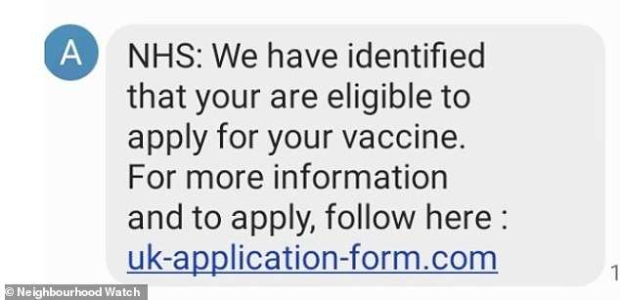

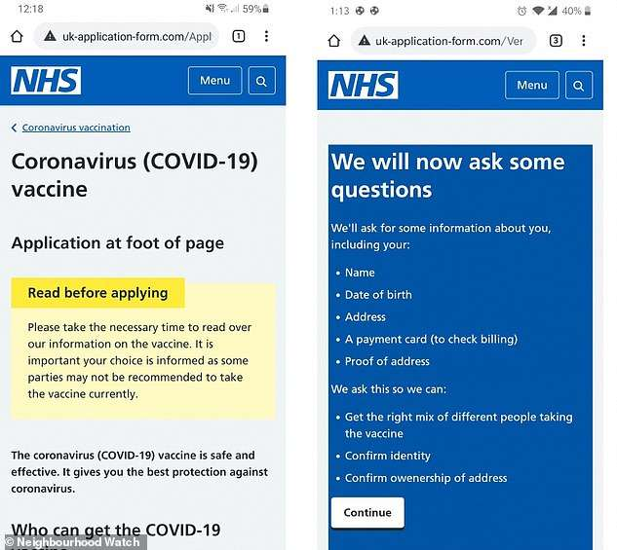

Fake text messages – examples above - have been sent out including links to fake NHS websites that ask recipients for bank details, supposedly for verification purposes
'The NHS will never ask you for banking details, passwords, or Pin numbers and these should serve as instant red flags.
'Do not provide any information to the scammers, but please also report suspicious messages to Action Fraud, as this provides intelligence and assists authorities in combating scams.'
"In some cases, people are asked to press a number on their keypad or to send a text message to confirm they wish to receive the vaccine. Doing so is likely to result in a charge being applied to their phone bill," the warning said.
Please be alert around scam text messages/cold calls telling you that you are eligible for a Covid vaccine, do not provide your payment details or any personal details in links attached. When your GP contacts you about the vaccine, they will not ask for payment!

