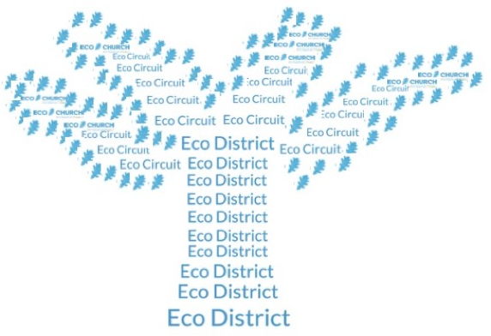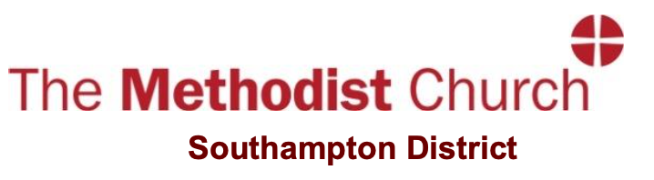

Launch of the Eco District group of the Southampton District of the Methodist Church

On December 2 our District Chair, Revd Andrew de Ville, launched first meeting on an Eco group of the Southampton District with an online meeting on Zoom. The meeting provided an introduction into Eco Church and the recording has been presented on the YouTube channel of the Southampton District of the Methodist Church which can be found on this link:
https://www.youtube.com/channel/UCXwKiDvZe3p2x3hMzt7jKNg

There are 5 videos available there:
- Introductory devotions by Andrew and an outline of Eco Church https://www.youtube.com/watch?v=RkQzPXTQgGI&t=8s
- Becoming an Eco Church – Paul Yarrien and Nick Langham https://www.youtube.com/watch?v=KfGGEBX4zW0
- Being an Eco Church – Jo Crocker https://www.youtube.com/watch?v=ZbUGgKd5obI
- Helping Eco Churches – Diane Kingston https://www.youtube.com/watch?v=E1mwVb6L3BI&t=24s
- An open discussion - https://www.youtube.com/watch?v=Hz8_ZzBhRvo

So, what now?
- Please use this material to help you with your own and your church’s pathways of creation care.
- The group discussion considered that the District was the appropriate scale to provide inspiration and support for those seeking to pursue Eco Church principles in the own churches and communities. It was also appropriate for influencing the direction of the Church countrywide. As the Church is seeking to define its Net Carbon Zero approach, this is very timely.
- We will therefore arrange a series of on-line gatherings which have a focus on a particular aspect of creation care and also provide time for sharing concerns and experiences. These will be open meetings available to all in the District. Please contact Sarah or myself if you have a proposal for topic.

John Evans
(johnxafs@icloud.com)
11 January 2022.

