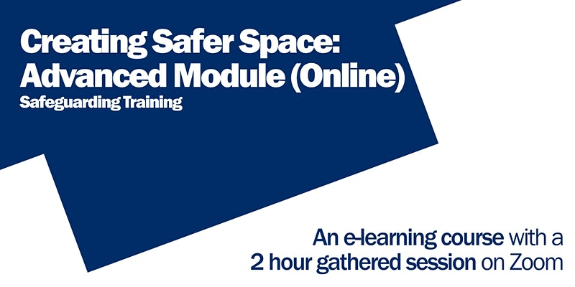

Once you have completed the online session you can book a gathered session below:
- Tuesday, 31 May 2022 @ 10.30pm - 12.30pm; and
Booking is via Eventbrite: Click here to book a place
- Tuesday, 7 June 2022 @ 3pm - 5pm; and
Booking is via Eventbrite: Click here to book a place
- Tuesday, 21 June 2022 @ 10am - 12pm; and
Booking is via Eventbrite: Click here to book a place
- Wednesday, 22 June 2022 @ 10am - 12pm; and
Booking is via Eventbrite: Click here to book a place
- Thursday, 23 June 2022 @ 10am - 12pm; and
Booking is via Eventbrite: Click here to book a place
- Monday, 4 July 2022 @ 10am - 12pm; and
Booking is via Eventbrite: Click here to book a place
- Tuesday, 5 July 2022 @ 7pm - 9pm; and
Booking is via Eventbrite: Click here to book a place
- Wednesday, 6 July 2022 @ 10am - 12pm; and
Booking is via Eventbrite: Click here to book a place
- Wednesday, 6 July 2022 @ 2pm - 4pm; and
Booking is via Eventbrite: Click here to book a place
- Friday, 8 July 2022 @ 10am - 12pm; and
Booking is via Eventbrite: Click here to book a place
- Monday, 11 July 2022 @ 7pm - 9pm; and
Booking is via Eventbrite: Click here to book a place

