Rev Helen Everard’s visit to Zambia in July 2023
I was invited to visit the Lusaka presbytery as I had offered hospitality on 3 occasions to visiting Zambian pastors( Deaconess Albertina Mwowo, Bishop Lordwell Siame and Rev Chris Njovu ). I spent 10 days in early July, originally to attend a ministers’ symposium. However this was cancelled so Bishop Lordwell put together a programme of visits to parishes in Lusaka, visits to Women’s Christian Fellowship groups, a radio interview on their radio station, a morning with the women’s ministry group and some tourist visits including a trip to Livingstone to see the Victoria Falls. I visited a rural town , Mumbwa, and was invited to preach there on the Sunday, as well as visiting Nambala secondary school nearby.
Reflections…what did I learn and what did I tell?
I observed that many of the music groups are made up of teenagers and young adults, some with instruments and of women; these sing mostly unaccompanied. All these different groups are invited to lead part of the worship on a Sunday. Their contributions are valued and the congregation certainly joined in singing with them in the service at Mumbwa. The singing time allowed for the congregation to finish coming into church until the church was very full. The groups are very joyful, and I think it must help the young people in the congregation to be involved. The practices demand quite a time commitment.
It was clear that the women of the WCF spend much of their time committed to activities in the church and the community. I was told that it is the women who attend the Bible study and the midweek services. Many of these women are widows and retired. I met some who had been nurses and had travelled to the UK and Europe. The women who were not yet members of the WCF needed to pass an oral examination – because, I was told, many do not read or write. These were varied in age from quite elderly to mothers with small children.
I was impressed by the amount of money they raise by tithes. These are sometimes not prosperous women yet they place great importance on giving and each section has its own charitable project.
They asked me about work in our communities. I told them about warm hubs this winter and foodbanks. I was struck by the fact that the URC co-operates with other churches to provide these sorts of facilities but the UCZ WCF works by itself.
The congregations are organised into sections; this is very necessary with such large congregations.
Many of the churches I visited in Lusaka are now occupying their 3rd building, the largest yet. The other buildings are used for the Sunday school and are often renovated to bring them up to a modern standard. So the congregations are always raising money to finish their own church buildings as well as for minsters’ salaries. Minsters pay youth workers out of their own pockets, as there are few youth workers but they are much needed.
The women Christian workers group consists of 30 ministers and deaconesses and they meet to support each other. They meet attitudes critical of women in the ministry, and at present there are no women bishops. They admitted that it is difficult to progress and that being one woman in the bishops’ meeting would be tough.
The women are members of an Africa-wide theological movement which shares work by female African theologians. They have conferences with topics such as family life, preparation for retirement, self-empowerment and spiritual growth. They donate to a mutual fund every month which is used to benefit the group.
They suggested that to share topics for prayer with women ministers in the UK would be beneficial for mutual support.
I suggested to several groups that I would share the joy I saw in Zambian churches with the UK congregations who can feel discouraged by the fact that they are older and see no young people staying in the church. Meeting the churches of Zambia - vibrant, worshipful and full - should help us in the UK to feel, not guilty, but thankful that such a harvest can be seen through God’s grace - and that God has a plan for us, remembering that we are all One in Christ and part of the world wide church, made to help each other as we can with God’s help.
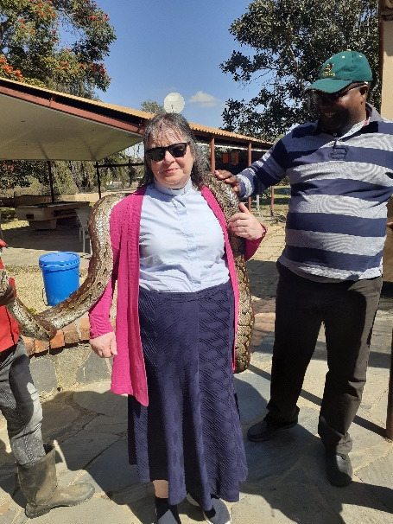
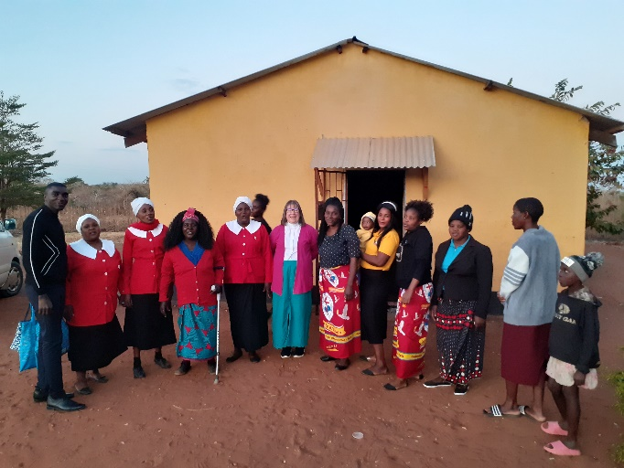
At Balmoral Church.

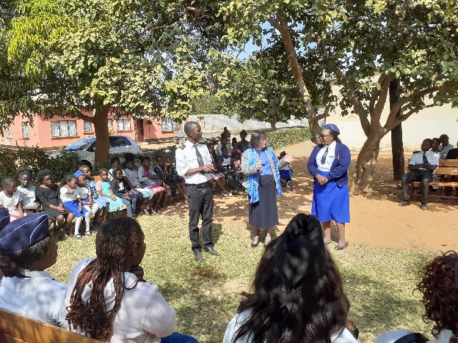
With Bishop Siame and a boa constrictor

At Mumbwa with the Boys & Girls Brigade

