**Domestic Abuse Posters and Stickers**

A range of posters and stickers for use in churches and church buildings are available at:

https://www.methodist.org.uk/safeguarding/policies-procedure-and-information/posters/

**Methodist Church Safeguarding Commitments and Key Contacts Posters**

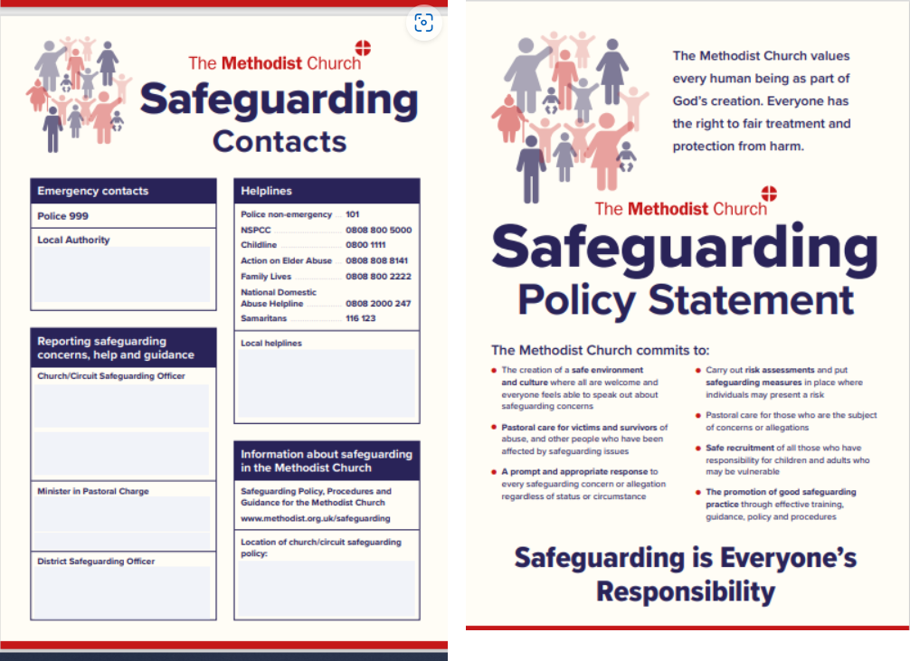

All Methodist churches, circuits and Local Ecumenical Partnerships (LEPs) that follow the Safeguarding Policy, Procedures and Guidance for the Methodist Church  should display in a prominent location:

Either

a)   copies of the safeguarding commitments and key contacts posters, completed in line with the guidance below

[**Safeguarding Commitments and Contacts Poster - English language version for Methodist churches**](https://www.methodist.org.uk/documents/11492/new_methodist_church_english_language_policy_commitments_and_contacts_posters-_N6jAPMb.pdf)

[**Safeguarding Commitments and Contacts Poster – English language version for LEPs**](https://www.methodist.org.uk/documents/11493/new_methodist_lep_english_language_policy_commitments_and_contacts_poster-wv21_cMFcgW9.pdf)

Please review the  guidance found at the link above before using the posters.  Posters may be printed at A4 or A3 size from the version supplied. The posters may also be used in other Methodist premises where this is deemed appropriate and helpful.

[**Guidance on using the Safeguarding Commitments and Key Contacts Posters**](https://www.methodist.org.uk/documents/11496/information_sheet_about_safeguarding_posters-wv-sept-2020_Phr9oGr.pdf)

Or

b)   a similarly designed local equivalent which contains the policy commitments contained within the Safeguarding Policy, Procedures and Guidance for the Methodist Church and similar contact information: The poster should also contain details of where a hard copy or digital version of the local safeguarding policy can be found.

Or

c)   a copy of the local safeguarding policy based on the templates available at the following link

[**https://www.methodist.org.uk/safeguarding/policies-procedure-and-information/policies-and-guidance/**](https://www.methodist.org.uk/safeguarding/policies-procedure-and-information/policies-and-guidance/)

**Domestic Abuse Posters and Stickers**

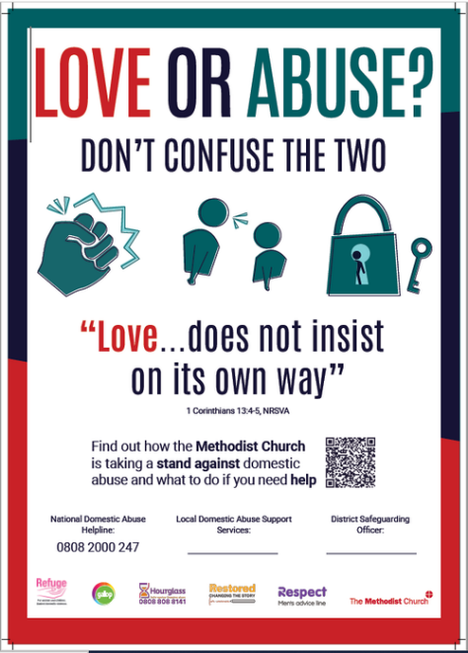

The Methodist Council adopted a policy on domestic abuse in 2021 and ~~now~~ the Domestic Abuse Planning Group has produced an A3 poster for display on church notice boards and small stickers intended for display behind toilet doors (which have been found to be an effective and discrete place to share important information).  The intention of the posters and stickers is to make clear the church’s commitment to highlighting the dangers of domestic abuse, in all its forms, and where people can find support to protect themselves.

As a church we can make a difference in highlighting issues such as domestic abuse, helping to remove the stigma that is often attached to the subject and thus helping to give victims and survivors the courage to come forward and seek support. Please feel free to download copies of the poster here.

[**Safeguarding Domestic Abuse Poster - September 2022**](https://www.methodist.org.uk/documents/11497/safeguarding_domestic_abuse_poster-september_2022_My3p25D.pdf)

**Domestic Abuse Stickers**

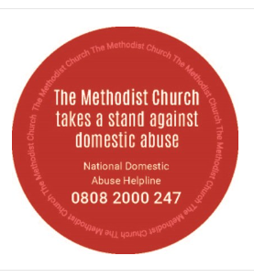

Sheets of 12 stickers can be ordered from Methodist Publishing