Safeguarding Sunday this year is:

Sunday 17 November 2024

You can register for a resource pack at: https://safeguardingsunday.org
This will provide all the material you need to run a Safeguarding Sunday Service.

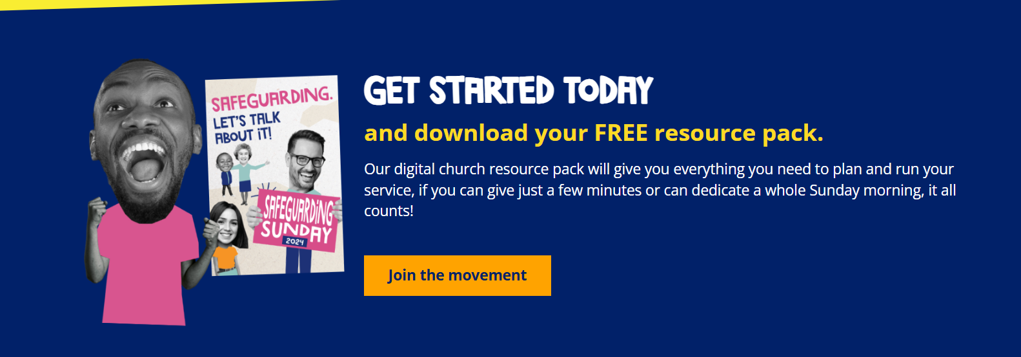

Things you may consider doing:

- Interview Church / Circuit SO about their role and then pray for them

- Interview someone in your church who works in safeguarding in some context

- Invite someone from a relevant group in the community – Women’s Refuge, etc

- For ideas on sermons please contact Jane Fisher – safeguarding@sdmc.org.uk

NEWS FLASH NEWS FLASH NEWS FLASH NEWS FLASH
We are pleased to announce that this year our District Chair Revd Rachel Bending and the District Chair for the Channel Islands will be providing a short video about safeguarding in the church. If you do nothing else please show this video.

Watch this space it will be posted here nearer the day.

Take the opportunity to ask those who are leading / preaching on Safeguarding Sunday to focus in some way on Safeguarding.

