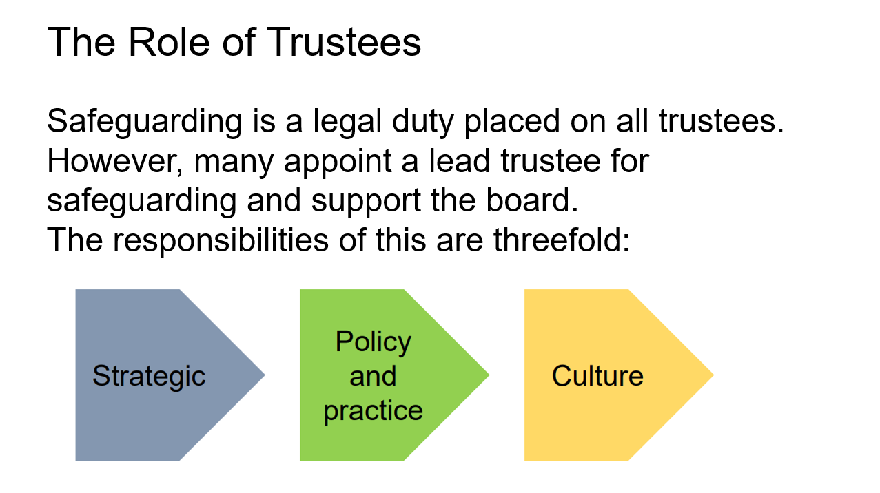

It is important Trustees understand the responsibilities on them in respect of Safeguarding. They may delegate the carrying out of the work but cannot delegate responsibility for safeguarding.