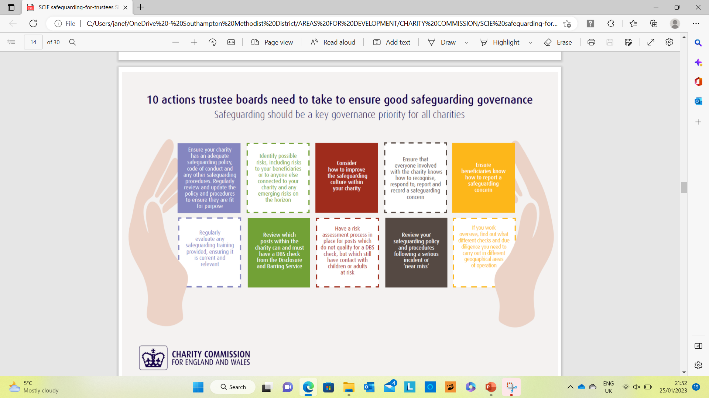

For more information on these and ideas for ways in which you, as Trustees, can ensure you are doing what is required by the Charity Commission please contact the DSO or your Circuit Safeguarding Officer.

