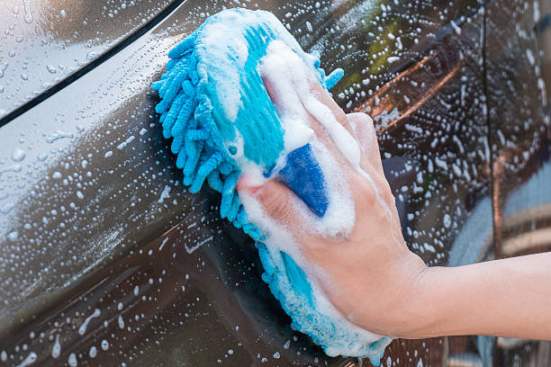

The Church of England’s modern slavery response, The Clewer Initiative, and Nottingham Trent University (NTU) have partnered to bring awareness to exploitation and slavery within the UK’s hand car wash sector.

Their new research, coinciding with the sixth anniversary of The Clewer Initiative’s Safe Car Wash App, aimed to categorise hand car washes by the likelihood of modern slavery practices.

However, it concluded that risks are universal across locations, emphasising a need for nationwide vigilance against exploitation.

This comprehensive study revealed that more than 90 per cent of hand car washes might be employing workers under illegal conditions.

NTU researcher Dr. James Hunter said: “We have identified a number of drivers that increase the likelihood of exploitation being present. For example, there is a 2.2 times greater chance of finding exploitation in a hand car wash in a neighbourhood containing a vehicle repairs business and a 1.75 times greater chance of finding exploitation in a hand car wash in a neighbourhood with a petrol station.

“However, the variation between our original model and the Safe Car Wash App based analysis is statistically small and leads us to conclude that, in reality, modern slavery and exploitation can occur in any business. This is more worrying than if there had been a particular pattern. No community, consumer or police force can take their eye off the ball.”

A 2018 government backed programme called the Responsible Car Wash Scheme established a code of practice for car wash businesses and found that barely any of the car washes met the criteria.

“The entire sector is endemically unlawful and non-compliant,” said NTU researcher Rick Pickford.

“Our work through the Home Office’s Modern Slavery Prevention Fund also highlighted the scale of non-compliance and unlawful practice across three local authorities in the UK.”

The Clewer Initiative has encouraged the public to download its Safe Car Wash App and submit reports every time they visit a hand car wash.

Since its launch in June 2018, the app has reportedly been instrumental in identifying businesses exploiting workers, with significant contributions to law enforcement efforts against modern slavery.

“A large number of police forces across the country use the data from the Safe Car Wash App to inform their investigations and so the more intelligence we can triage for them, the more effective their policing will be,” said Caroline Virgo, director of The Clewer Initiative.

The app has been downloaded more than 40,000 times.

Please go to: <https://theclewerinitiative.org/campaigns/safe-car-wash> to access the app.