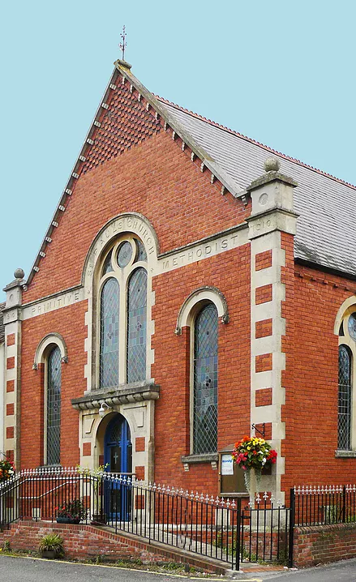

Bishops Waltham
United Free Church

Child-friendly Summer Fayre
Saturday 9th August 10:00-12:00

Lots of Children’s activities (including pocket money toy stall)

Contact Jenny for more details on 07973529415

