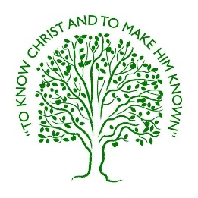
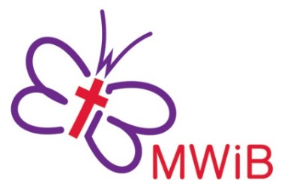
Methodist Women in Britain
World Federation Area Vice President for Britain and Ireland 2026-2031

Role Description

The aims of MWiB:
  - Bringing women together to know Christ and to make him known.
  - Encouraging, equipping and enabling women to serve God in the church, the community and the world.
  - Connecting women in Britain with women worldwide.

The WFMUCW Area Vice President is the link between MWIB and the WFMUCW, representing MWiB as a World Federation officer. She will work closely with the World Federation Area President, the MWiB executive team and the Global Relationships team in the British Methodist Church. She will, where possible, attend WFMUCW meetings and events as required, and MWiB Executive meetings and Trustees meetings during the year. She will support and enable the continuing development of the British Helen Kim Memorial Scholar and help to organise the next Area Seminar. She will hold office for five years, beginning in August 2026 at the World Assembly in Auckland, New Zealand

Responsibilities within the Executive of Methodist Women in Britain
The Executive officers, as a team, facilitate the Trustees, the Connexional governing body of MWiB. They prepare for Trustee meetings, implement the decisions of the Trustees and take the work forward between Trustee meetings. Executive officers provide information, spiritual stimulus and leadership in a way which releases the gifts of the Trustee members. All the officers share the responsibility to communicate effectively and to advocate the aims of the movement, building mutual trust and contributing their varied skills and talents to the common task. They may not all have the same capacity for travel but will nevertheless inform themselves about the work of MWiB and WFMUCW and issues which affect women in Britain and around the world.

Responsibilities within the World Federation of Methodist and Uniting Church Women
The World Federation has nine areas; Britain belongs to the Europe: Britain and Ireland Area, which comprises two units: (i) Britain and (ii) Ireland. Each Area has a President and a Vice-President; in our area these two posts alternate between the British and Irish Units. For 2026-31 Britain is responsible for appointing the Area Vice President. The responsibilities and tasks associated with this role are set out in the WFMUCW constitution and Handbook.

The Area Vice President shall:
- Attend Executive Committee Meeting/s of the World Assembly Executive Committee meeting if the Area President is not available
- Attend Pre- and Post-World Assembly Executive Committee Meetings
- Assist the Area President in the planning of Area Programs and in the presentation of the work of the World Federation within her area
- Assist the Area President to promote United Nations programs in her area
- Represent the office of Area President, as necessary, in her absence
- Assume the office of the Area President should the office become vacant due to resignation or incapacity
- Submit an annual report to the World President and the World Secretary on her activities. She shall submit a written report to the Executive Committee

All expenses entailed in carrying out this role are re-imbursed by MWiB or WFMUCW. An application form and further details about the MWiB Executive and the World Federation of Methodist and Uniting Church Women can be found on the website www.mwib.org.uk or email our Communications Officer communications.mwib@gmail.com

For questions about the role contact Barbara Easton britainireland.president@wfmucw.org

Closing date for applications is Monday 10th November 2025
Interviews will be held at Tavistock House, London on the afternoon of Monday 24th November 2025

