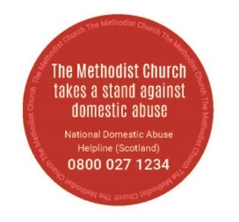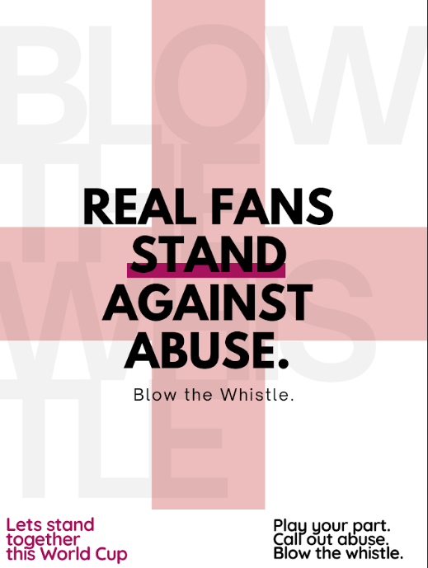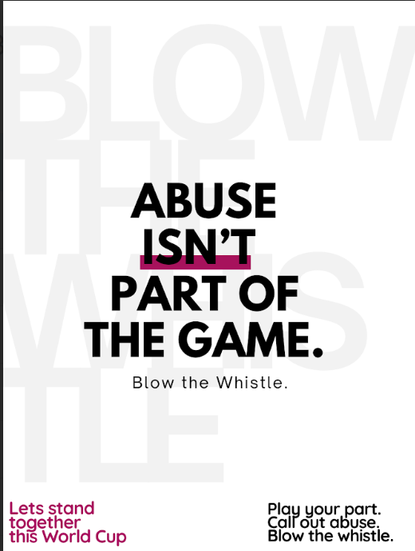
The World Cup kicks off on 11th June. Evidence from previous football competitions indicates they can lead to a significant increase in domestic abuse. Factors such as alcohol, drug use and gambling may exacerbate existing issues, leading to an increase in domestic abuse incidents. A study by Lancaster university found that domestic abuse incidents rose by 38% when England lost a match and by 26% when they won or drew.
There is NO EXCUSE for domestic abuse. It is ALWAYS wrong. The ONLY person to BLAME is the PERPETRATOR. The BIBLE does NOT give any justification or support to abusive behaviour. It is NOT CHRISTIAN BEHAVIOUR.

If you are experiencing abuse, you don’t have to put up with it.
The church has resources to support anyone experiencing abuse. A number of other organisations have also prepared material to support anyone experiencing abuse during the World Cup.
- Methodist Domestic Abuse information may be found at: https://www.methodist.org.uk/safeguarding/domestic-abuse/
- Stop It Coming Home - World Cup Campaign - Solace Women’s Aid https://share.google/I3uBvWnf8dqeNFkiv
- https://www.restored-uk.org
- https://www.firstlight.org.uk/get_involved/blowthewhistle/ - a variety of posters can be found at: https://drive.google.com/drive/folders/1wWWM9cxV8WjFrNSkhhDhpuJlld1kGen2
