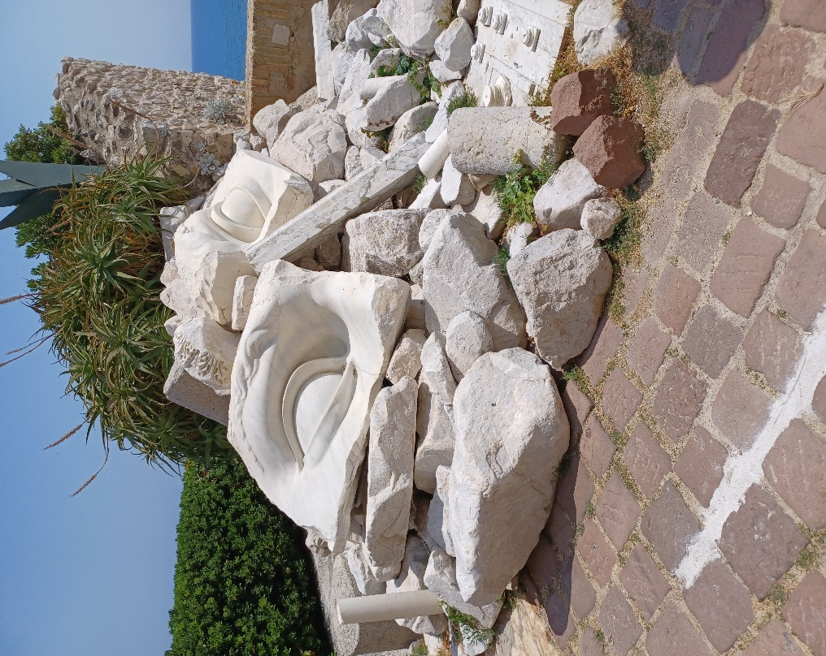
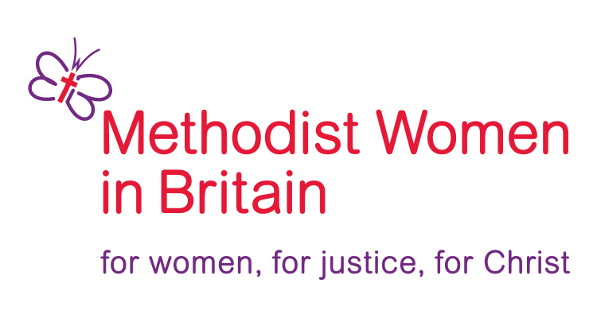

Southampton District Day @ Chandler’s Ford
Methodist Church SO53 2GJ
Saturday 10th October
10.00 for 10.30 a.m. to 3.30 p.m.
Keynote speaker:
Rev’d Rachel Bending (District Chair)
Snes and silence

Stones and Silence
Rising in Rubble

A day to consider the resilience of women.
Including: News from New Zealand’s WFMUCW meeting in August
Workshops with: Bekah Legg from Restored charity who support women
Becca Wakelin about SHE our District Partnership for 2026/27 through All we Can
Rachel Bending exploring how women respond to challenging situations
Creche available – to book a place please email <anne-marie.jenkins@outlook.com.
Bring your lunch. Drinks provided. Donations invited to support MWiB District funds. Parking at the church. 10 minutes walk from station.
All are Welcome. Come with a friend or two or even three. See you there.

